**Use Case Specification**

ID: 1  
Title: Create Account  
Criteria: How will adding a volunteer affect SKC’s data?  
Risk Level: Low  
Risk: Inputting incorrect data could cause issues with accessing the website but can easily be corrected

Trace Matrix: This can be traced to a functional requirement of the customer creating their account.  
  
ID: 2  
Title: Edit Account  
Criteria: How will editing account data affect SKC’s data  
Risk level: Low  
Risk: may create edit anomalies leading to minor data redundancy

Trace Matrix: This can be traced to a functional requirement of the customer modifying their account.  
  
ID: 3  
Title: Delete Account  
Criteria: How will deleting account data affect SKC’s data  
Risk level: Low  
Risk: May create delete anomalies leading to minor data redundancy

Trace Matrix: This can be traced to a functional requirement of the customer or Karoline, deleting the customer’s account.  
  
ID: 4  
Title: Create Order  
Criteria: How will creating an order affect SKC  
Risk level: High  
Risk: inefficiently collecting data may lead to incorrect order or order fulfillment

Trace Matrix: This can be traced to a functional requirement of the customer creating an order for Karoline.

Flow: 1. User loads order form.

2. User enters first name

3. User enters middle name (optional)

4. User enters last name

5. User selects date of birth

6. User selects whether delivery or carryout

7. User selects 1 or more menu item from item drop boxes.

8. User selects an extra option (cake filling or cookies)

9. User selects if they want to save order

10. User enters phone number

11. User enters email address

12. User selects delivery/availability date

13. User inputs any additional comments for order in the text box (optional)

14. User uploads any images using image button to order.

15. User clicks ‘Next’ button

16. The order is sent to and stored by the database management system.

ID: 5  
Title: Modify Order  
Criteria: will modifying order impact SKC  
Risk Level: Low  
Risk: modifying the order may lead to problems with order fulfillment

Trace Matrix: This can be traced to a functional requirement of Karoline editing a customer’s order.

Flow: 1. Karoline opens existing order

2. Karoline changes any existing attribute

3. Karoline clicks button to save changes.

4. The database management system saves the order again.

ID: 6  
Title: Delete Order  
Criteria: will deleting order impact SKC  
Risk Level: Low  
Risk: accidently deleting an order or deleting the incorrect order

Trace Matrix: This can be traced to a functional requirement of Karoline or the customer deleting an order.

Flow: 1. User or Karoline views an existing order

2. User clicks delete order.

3. DBMS removes the order from database storage.  
  
ID: 7  
Title: View Previous Orders  
Criteria: will viewing previous orders impact SKC data  
Risk level: low  
Risk: viewing previous order data presents minimal risk

Trace Matrix: This can be traced to a functional requirement of Karoline viewing previous customer orders.

Flow: 1. Karoline logs in to admin account.

2. Karoline finds a previously completed order in her database.

3. Karoline clicks ‘view order’

4. DBMS retrieves the information for said order.

ID: 8  
Title: Fulfill Order  
Criteria: How does fulfilling orders impact SKC data  
Risk level: High  
Risk: order fulfillment is critical to day to day business as well as tracking of the information  
Trace Matrix: This can be traced to a functional requirement of Karoline fulfilling an order for a customer.

Flow: 1. Karoline completes order for customer.

2. Karoline views order in admin account.

3. Karoline clicks ‘fulfill order’

4. The charge for order is calculated by DBMS

5. The order is completed by Karoline

6. DBMS saves order under ‘previous orders’

ID: 9  
Title: Terminate Employee  
Criteria: How does terminating an employee impact SKC data  
Risk level: low  
Risk: terminating employees may lead to data redundancies in the database on employee data

Trace Matrix: This can be traced to a functional requirement of Karoline firing a current employee.

Flow: 1. Karoline contacts employee.

2. Karoline removes employee information from the schedule/database

ID: 10  
Title: Hire Employees  
Criteria: How does hiring employees impact SKC’s data  
Risk level: low  
Risk: hiring employees may lead to incorrect data being stored or problems with properly storing employee data

Trace Matrix: This can be traced to a functional requirement of Karoline to hire an employee.

Flow: 1. Karoline performs an interview with a potential employee.

2. Karoline runs a personal analysis on the individual.

3. Karoline contacts the individual via Phone informing them of their hiring.

4. Karoline asks employee for their banking information.

5. Employee provides information to Karoline.

6. Karoline enters the information into the database.

7. Karoline saves the information.

ID: 11  
Title: Ship Order  
Criteria: How does shipping an order impact SKC’s data  
Risk level: High  
Risk: Properly shipping an order and tracking and logging this information is critical to SKC business and data  
Trace Matrix: This can be traced to a functional requirement of Karoline herself or contract to another party shipping an order to a customer.

Flow: 1. Karoline completes an order.

2. Karoline communicates with customer for delivery information via email or website.

3. Location and time is selected

4. The order is either shipped, picked up, or delivered.

5. Customer receives order.

ID: 12  
Title: Order Supplies  
Criteria: How does ordering supplies impact SKC’s data  
Risk level: high  
Risk: not properly ordering or tracking supplies negatively impacts SKC and it’s data

Trace Matrix: This can traced to a functional requirement of Karoline herself or possibly extend to a supply company as her business expands

Flow:

1. Karoline notices cooking supplies are low.

2. Karoline orders/buys more supplies for business

3. Transaction occurs

4. Transaction tracked in accounting records

5. Accounting records stored in the DBMS

ID: 13  
Title: Track supplies expense  
Affect SKC’s data  
Risk level: High  
Risk: tracking supplies’ expenses is critical to SKC’s business and data

Trace Matrix: This can be traced to functional requirement of karoline herself and possibly extend to a supply company in the future as her business expands

Flow:

1. Karoline buys supplies for business
2. Karoline tracks expenditures in accounting application
3. Data is stored in DBMS

ID: 14  
Title: Update Website in Content Management System  
Criteria: How does updating the Website affect SKC  
Risk level: Low  
Risk: not properly updating the website could lead to difficulties with the business, but we are are not projecting any drastic changes in the immediate future  
Trace Matrix: This can be traced to a functional requirement of Karoline herself and any development content management team she may contract in the future.

Flow:

1. Video and photo content generated regarding the business
2. Karoline uploads media to social media
3. Karoline uploads media to the DBMS
4. Media is transferred from DBMS to CMS
5. Media is transferred from

ID: 15  
Title: Update order form products  
Criteria: How does having a properly updated order form affect SKC  
Risk level: High  
Risk: Not having properly updated order information on the site will allow for invalid orders to be made leading to a myriad other complications

Trace Matrix: This can be traced to a functional requirement of Karoline herself.

ID: 16  
Title: Complete payment information

Description: The customer must input their payment information, things like a credit card or a paypal account, into the payment form to complete their order. This is a high risk use case because completing the payment information accurately allows for transactions to take place and the business to make money. Completing payment information can be traced to a functional requirement of the customer completing an order and paying Karoline.

Basic Flow:

1. Customer loads Payment Form
2. Customer views Order Summary
3. Customer clicks Paypal plug-in
4. Customer enters name on credit/debit card
5. Customer enters card number
6. Customer enters expiration date
7. Customer enters CVC
8. Customer is taken to billing address form through paypal
9. Customer enters first name
10. Customer enters last name
11. Customer enters address
12. Customer enters city
13. Customer enters state
14. Customer enters zip code
15. Customer finishes entering all of their information

Alternative Flow:

1. Customer loads Payment Form
2. Customer views Order Summary
3. Customer clicks Paypal plug-in
4. Customer uses existing Paypal account to complete the transaction
5. Customer uses saved billing address through Paypal
6. Customer finishes entering all of their information

Special Requirements: The customer already has a Paypal account with information already stored and ready to use when the customer loads the Paypal plug-in. This will trigger the alternative flow of events, and decrease the amount of steps for this use case.

Pre-conditions: The customer has already completed the order form, and is ready to pay.

Post-conditions: The customer has input their information, and Paypal is processing it to complete the transaction.

ID: 17  
Title: Contact Karoline (via Form)  
Criteria: How does contacting Karoline affect SKC  
Risk Level: low  
Risk: although contacting Karoline may be important now, our desired outcome is to reduce the need for this communication, meaning that the need to contact Karoline directly will have less risk for the company.

Trace Matrix: This can be traced to a functional requirement of communication with a customer.  
  
ID: 18  
Title: Respond to Customer  
Criteria: how does responding to consumer inquiries affect SKC  
Risk level : Low  
Risk: communication is key, but does not have devastating impacts on order completion or data integrity

Trace Matrix: This can be traced to a functional requirement of communication with a customer.  
   
ID: 19  
Title: Post on Social Media  
Criteria: How does posting to social media platforms affect SKC  
Risk level: High  
Risk: Social Media is a key method of communicating with SKC’s current consumer base so being able to access these platforms and use the effectively is key

Trace Matrix: This can be traced to a functional requirement of Karoline managing her social media platforms.   
  
ID: 20  
Title: Collect Payment  
Description: Sweet Karoline’s Cakes collects payment from the customer through Paypal after the customer has completed the transaction and the payment has been processed by Paypal. This is a high risk use case because collecting payments and tracking the transactional data is critical to the business. Collecting payment can be traced to a functional requirement of Karoline receiving a payment for her goods and services.

Basic Flow:

1. SKC receives order from customer
2. SKC signs into Paypal
3. SKC collects payment via Paypal account

Alternative Flow: There is no alternative flow of events

Special Requirements: SKC has a business Paypal Account, which she should have since Paypal will be handling all transactions on the finished website, if she doesn’t already have one.

Pre-conditions: The customer has completed the transaction, and everything has been processed by Paypal.

Post-conditions: SKC has received payment for the order.   
  
ID: 21  
Title: Process Payment  
Criteria: How does processing payments affect SKC  
Risk Level: High  
Risk: Processing payments is critical for online transactions

Trace Matrix: This can be traced to a functional requirement of Karoline receiving a payment for her goods and services.

ID: 22  
Title: Pay Employees  
Criteria: How does paying employees impact SKC  
Risk level: Low  
Risk: Paying employees is important to maintaining these employees. This data should be tracked

Trace Matrix: This can be traced to a functional requirement of Karoline to transfer the appropriate payment through the employees checking account.

Flow: 1. Karoline uses the Banking information that was given to her while hiring an employee.

2. Karoline links her work checking account with the employee checking account.

3. Karoline requests for a certain amount of money to be transferred to a given employees account.

4. The request is recognized and the money is transferred.  
  
ID: 23  
Title: Request a Quote  
Criteria: How does consumers ability to request a quote affect SKC  
Risk level: High  
Risk: Consumers may want specialty orders and requesting a quote can allow them to make a decision on a purchase

Trace Matrix: This can be traced to a functional requirement of the customer creating an order for Karoline.  
  
ID: 24  
Title: Provide Quote  
Criteria: How does SKC’s ability to provide a quote affect their business  
Risk level: High  
Risk: An accurate quote may guide a consumer towards a purchase

Trace Matrix: This can be traced to a functional requirement of the customer creating an order for Karoline, and Karoline completing that order.  
  
ID: 25  
Title: Add Item  
Criteria: How does SKC’s ability to add items impact their business  
Risk level: Low  
Risk: As the business changes SKC will want to add items to their menu

Trace Matrix: This can be traced to a functional requirement of adding new items into the Business’ website.  
  
ID: 26  
Title: Update Item  
Criteria: How does skc’s ability to update items impact their business  
Risk level: Low  
Risk: As the business changes SKC will want to update items

Trace Matrix: This can be traced to a functional requirement of updating items in the Business’ website.  
  
ID: 27  
Title: Delete Item  
Criteria: How does skc’s ability to delete items impact their business  
Risk level: Low  
Risk: As the business changes SKC will want to deleteitems

Trace Matrix: This can be traced to a functional requirement of deleting items in the Business’ website.  
  
ID: 28  
Title: Add Item to cart  
Criteria: How does end-users add item to cart affect SKC  
Risk Level: High  
Risk: Without this ability online purchases cannot be made  
Trace Matrix: This can be traced to a functional requirement of adding items in the Business website.

ID: 29  
Title: Record costs  
Criteria: How does recording costs impact SKC’s data  
Risk level: High  
Risk: Recording costs are critical for making sure SKC is profitable  
Trace Matrix: This can be traced back to a functional requirement of karoline and possibly any accounting firm contracted in the future to analyze her companies expenditures

Flow

1. Transaction occurs involving expenses

2. Transaction tracked in accounting records

3. Accounting records stored in the DBMS

ID: 30  
Title: Record income   
Criteria: How does recording income impact SKC’s data  
Risk level: High  
Risk: Recording income is critical for making sure SKC is profitable

Trace matrix: This can be traced back to a functional requirements of karoline and possibly any accounting firm contracted in the future to analyze her companies income and capital.

Flow:

1. Transaction occurs

2. Transaction tracked in accounting records

3. Accounting records stored in the DBMS

ID: 31  
Title: Record number of hours worked  
Criteria: How does recording hours worked impact SKC’s data  
Risk level: High  
Risk: Recording hours worked is critical for making sure SKC is profitable

Trace matrix: This can be traced back to a functional requirement of Karoline’s and possibly any person in the future contracted to record this data.

Flow:

1. Weekly shift is planned out
2. Workers are assigned shifts
3. Workers hours are tracked accounting for lunch breaks etc on time cards
4. Time cards are uploaded into DBMS
5. Time cards are used with accounting system to generate payroll

ID: 32   
Title : View Information about Karoline  
Criteria: How does viewing information about Karoline affect SKC  
Risk level : Low  
Risk: Some consumers may be more persuaded to make a purchase if an about the owner information is offered.   
Trace Matrix: This can be traced to a functional requirement of customers.

ID: 33  
title: Remove item from cart  
Criteria: How does an end-users ability to remove a cart item affect SKC  
Risk Level: High  
Risk: Removing and adding items to a cart is critical for end-users utilizing the website for transactions  
Trace Matrix: This can be traced to a functional requirement of removing items from the Business website.

Flow: 1. A customer clicks on the remove item icon on the cart.

2. The request is completed.

ID: 34  
Criteria: Update Cart  
Criteria: How does an end-users ability to update a cart item affect SKC  
Risk Level: High  
Risk: Removing and adding items to a cart is critical for end-users utilizing the website for transactions  
Trace Matrix: This can be traced to a functional requirement of updating the cart on the Business website.

ID: 35  
Criteria: Delete Cart  
Criteria: How does an end-users ability to delete a cart item affect SKC  
Risk Level: High  
Risk: Removing and adding items to a cart is critical for end-users utilizing the website for transactions  
Trace Matrix: This can be traced to a high level functional requirement. If a cart is deleted it may interrupt other parts of the Business website.

Flow: 1. A customer requests for their entire order to be deleted.

2. The request is fulfilled and the cart is deleted.

ID: 36  
Title : Input Shipping Information  
Criteria: How does an end user effectively inputting their shipping information affect SKC  
Risk level: High  
Risk: Without the proper shipping information than it may be difficult to complete an order.

Trace Matrix: This can be traced to a high level functional requirement. Without accurate information an order may not be able to be completed.  
  
ID: 37  
Title:Display product information  
Criteria: How does displaying the product information on their webpage affect SKC  
Risk level: low  
Risk: Inaccurate product information will lead to unwanted consumer purchases

Trace Matrix: This can be traced to a functional requirement of being able to keep accurate information up on the website.  
  
ID: 38  
Title: Edit product examples/information  
Criteria: How does SKC’s ability to edit product examples/info affect them.  
Risk level: low  
Risk: SKC will want to accurately display information about the products it is selling

Trace Matrix: This can be traced to a functional requirement of being able to keep accurate information up on the website.  
  
ID: 39  
Title: Delete product information  
Criteria: How does SKC’s ability to delete product info affect them.  
Risk level: low  
Risk: SKC will want to accurately display information about the products it is selling

Trace Matrix: This can be traced to a functional requirement of being able to keep accurate information up on the website.  
  
ID: 40  
Title: Display business information  
Criteria: How does SKC’s ability display its business information affect them.  
Risk level: low  
Risk: SKC will want to accurately display information about its business

Trace Matrix: This can be traced to a functional requirement of the customer and Karoline viewing any posted business information on the website.

Flow: 1. User/Karoline enters website home page.

2. User/Karoline views any business information posted by Karoline.

ID: 41  
Title: Edit business information  
Criteria: How does SKC’s ability edit its business information affect them.  
Risk level: low  
Risk: SKC will want to accurately edit information about its business

Trace Matrix: This can be traced to a functional requirement of allowing Karoline to edit any existing posted business information on the website.

Flow: 1. Karoline logs in to admin account

2. Karoline makes edit to posted business information

3. Karoline saves any edits

4. DBMS stores the updated data.

5. The website is updated with the edits  
  
ID: 42  
Title: Delete business information  
Criteria: How does SKC’s ability delete its business information affect them.  
Risk level: Low  
Risk: SKC will want to accurately delete information about its business

Trace Matrix: This can be traced to a functional requirement of Karoline needing to be able to Add, Update, and Delete Business Information.

Flow: 1. Karoline logs in to admin account

2. Karoline deletes any unwanted information from website

3. Karoline saves deletions

4. DBMS deletes said information

5. The website is updated without the deleted information

**Use Case Diagrams**

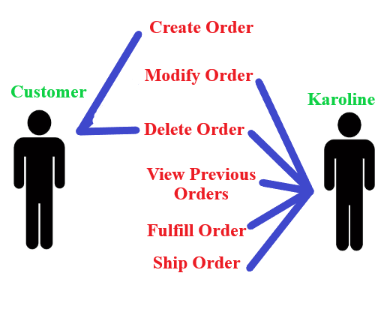

**Order Group Use Case Diagram:** The customer is able to create their own order as well as delete if they choose to not have a cake. Karoline is able to make changes to an order per the customer’s request. Karoline can view any previous orders and will fulfill and ship orders to the customer.

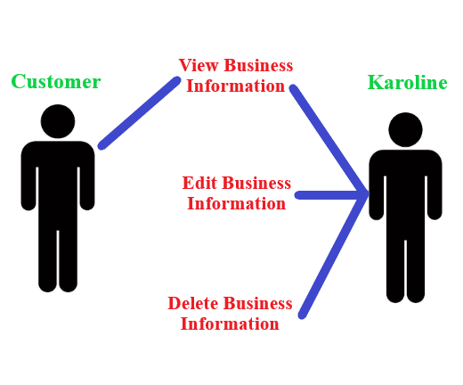

**Business Information Diagram:** The customer can view any business information that Karoline posts. Karoline can edit any information she has posted and delete it.

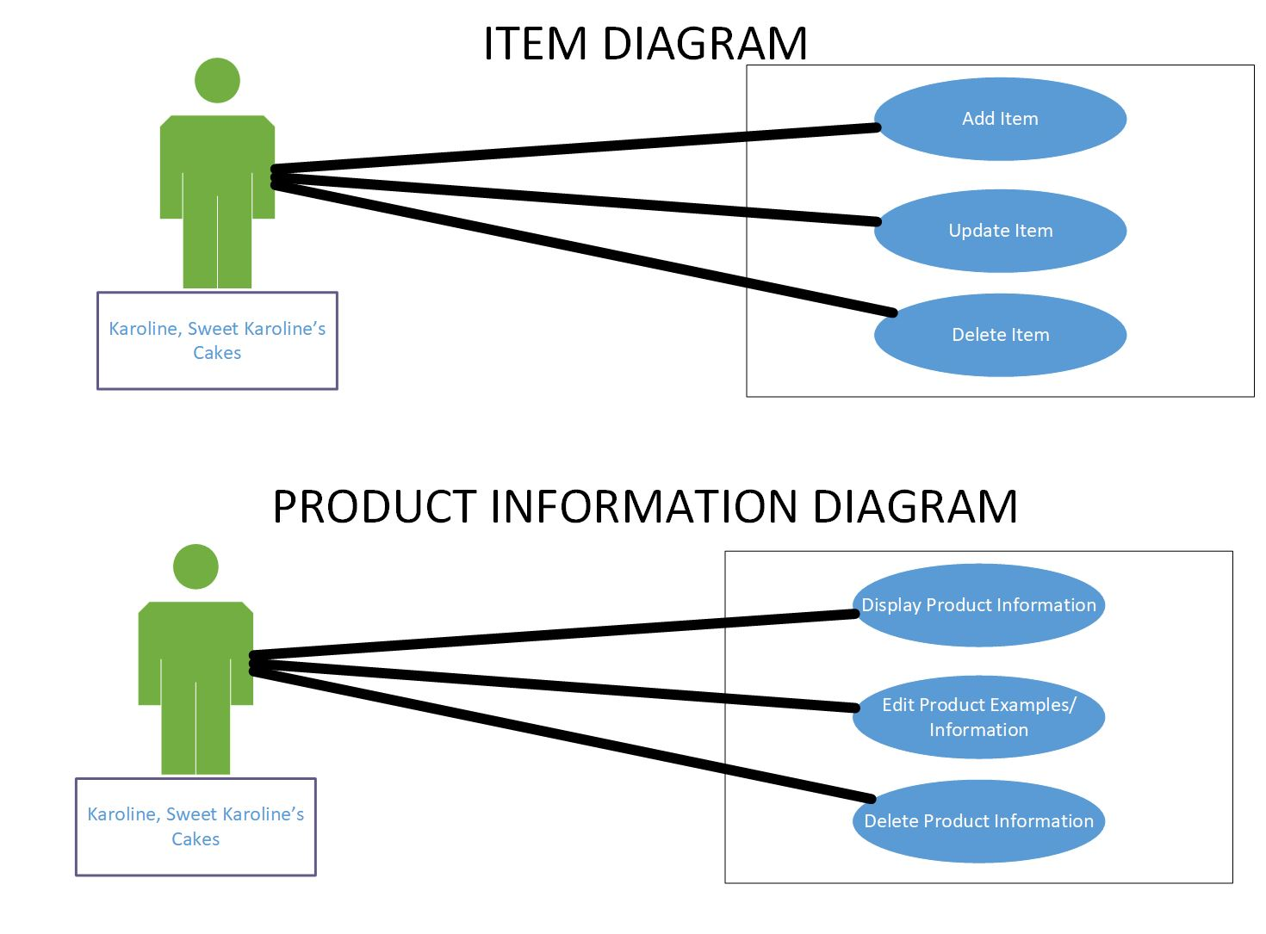

The above use case diagrams show the actor Karoline, interacting with the system. It shows that Karoline is able to add items, update items, and delete items. It also shows the Karoline can display product information, edit product information, and delete product information.

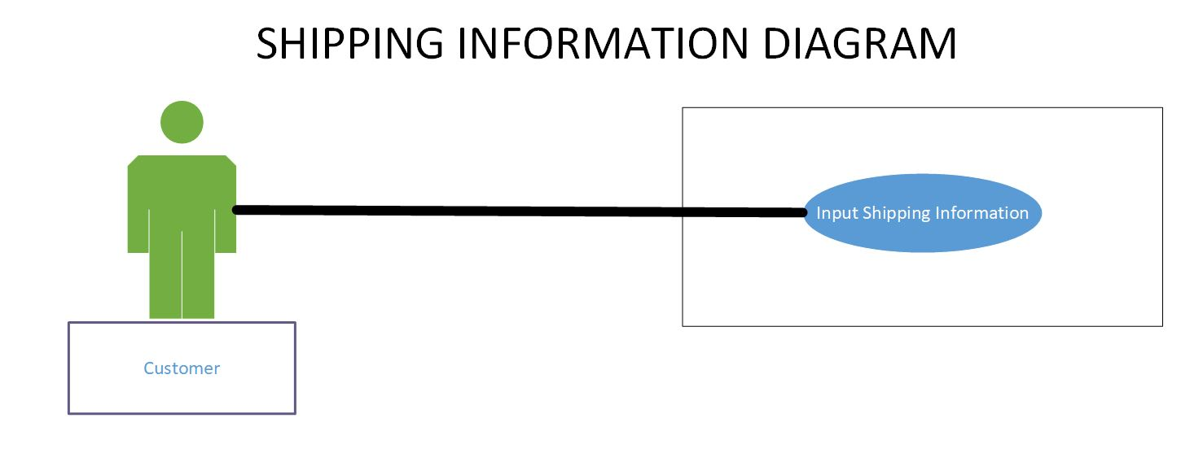

The above use case diagrams show the actor, the customer, interacting with the system. It shows that the customer is able/responsible for inputting their own shipping information.

**The Payment Process**

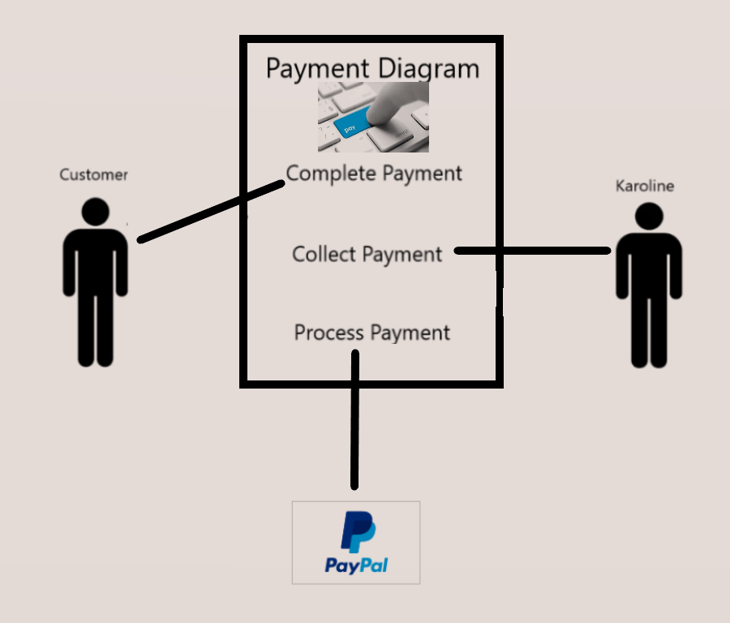

The diagram shown above displays the use case and the parties involved in processing payments received by Sweet Karoline’s Cakes. The customer supplies their payment information to complete the order and the information is processed by Paypal. Sweet Karoline’s collects the payment at the end of the process.

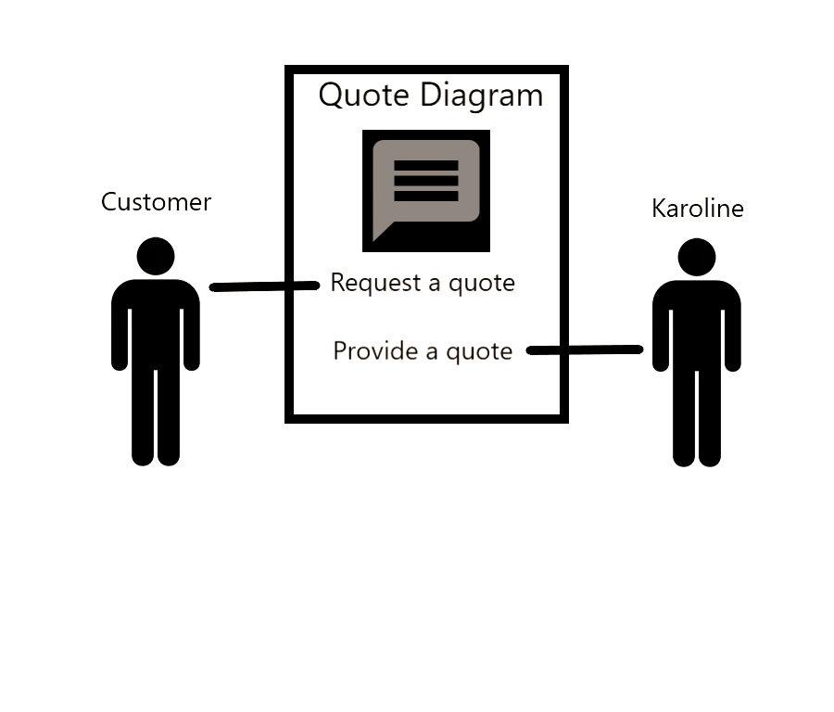

**Creating a Quote:** This diagram displays the process in which the customer asks Sweet Karoline’s Cakes for a quote on specialty or custom cakes and Sweet Karoline’s provides the with this information.

**Account Information Diagram:**

In this Account Information diagram, the customer is able to create, edit, and delete their account at any moment. Karoline is unable to create or edit a customer’s account, but she has the ability to delete a customer’s account.

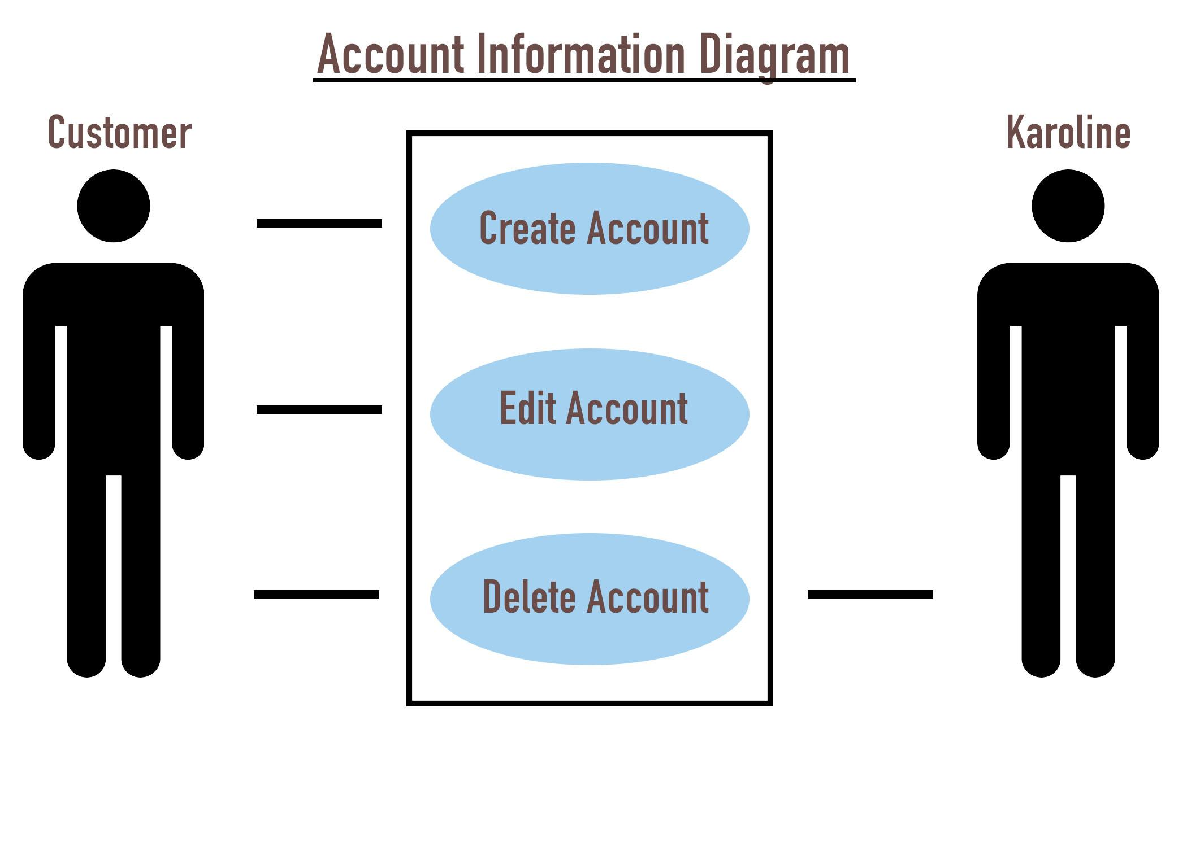

**Communication Diagram:**

In this Communication diagram, the customer is able to contact Karoline via the form on her website. Karoline will receive the message and can respond to the customer. Karoline also has the ability to post on her social media page. Karoline can post announcements and upcoming events on her page.

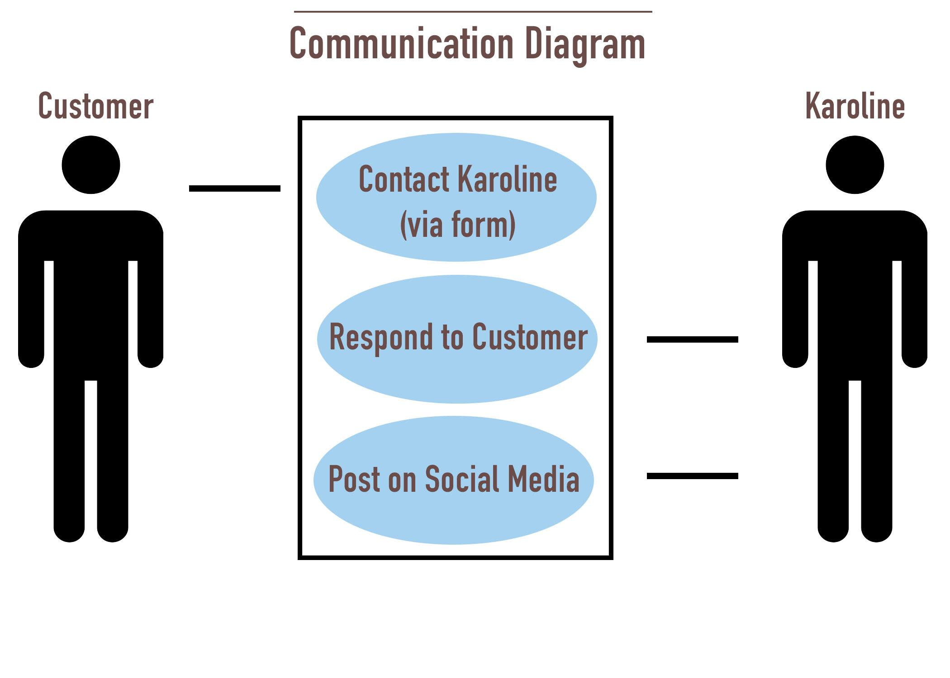

**CART DIAGRAM:** In this Cart Diagram, customers are given the option to remove items from their cart, update/add items to their cart, and delete their cart.

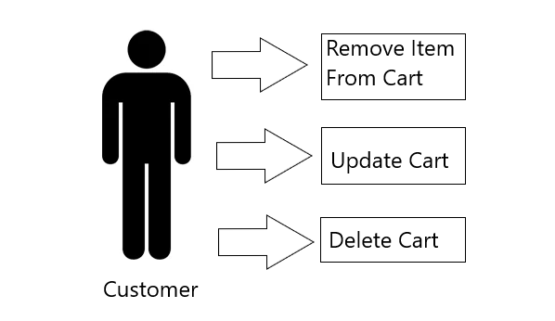

**EMPLOYEE DIAGRAM:** Karoline has the ability to terminate a current employee which cuts them from the payroll. Karoline may also hire an employee which adds them to the payroll. Karoline also has the ability to pay each employee individually for their work.

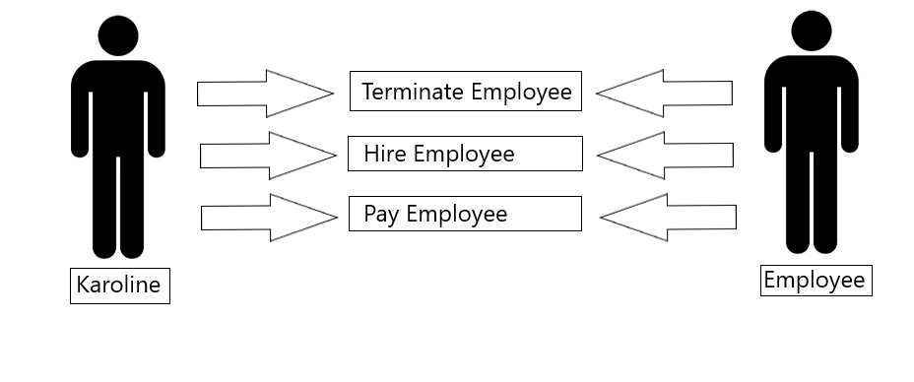

**TRACK SUPPLIES EXPENSE DIAGRAM**: SKC creates transaction data when it orders and tracks supplies it uses to produce goods. This data alongside consumer transactional data is stored in the dbms.

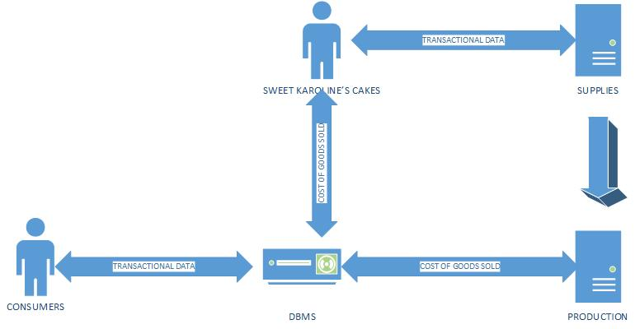

**ORDER SUPPLIES DIAGRAM**: SKC creates transactional data which it uses to complete supply orders and track supplies. This data is stored in the DBMS.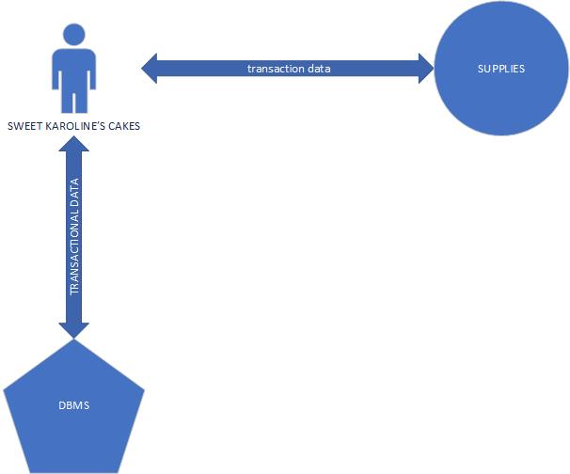

**TIME CARD DIAGRAM**: Employees create data which is stored in the DBMS this data is then used to complete time cards, which then are also stored in the DBMS.

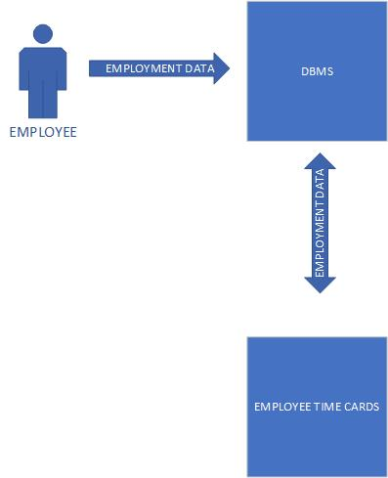

**UPDATE CMS DIAGRAM**: SKC creates content which it distributes to its social media platforms and then uploads this to its CMS which updates the images displayed on the website

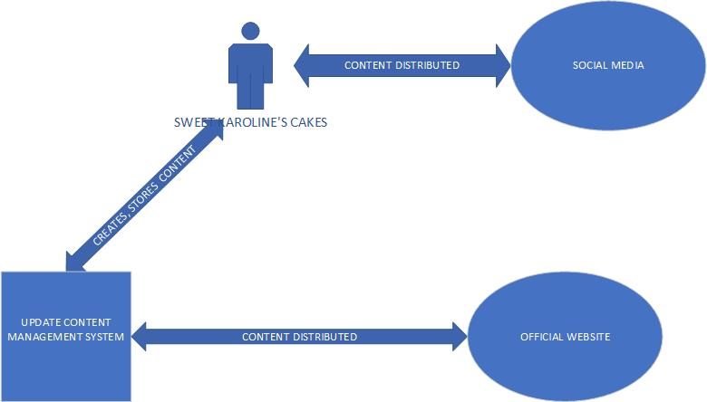

**RECORD COSTS DIAGRAM**: SKC tracks COGS utilizing its TPS and accounting data which is stored in the DBMS. This accounting data is then used to created ledgers, journals and other accounting measures of recording costs.

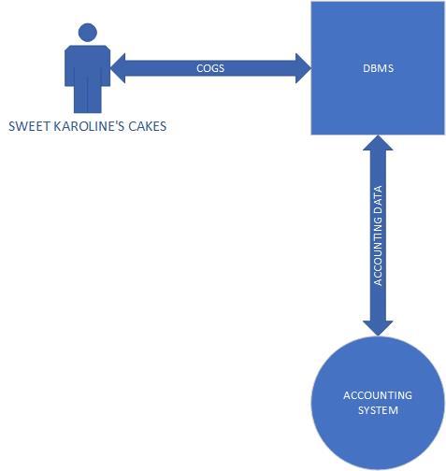

**RECORD INCOME DIAGRAM:** Consumers generate data on purchases which can then be used to evaluate income. It is stored into the DBMS via the TPS and then used by the database administrator SKC to generate accounting data.

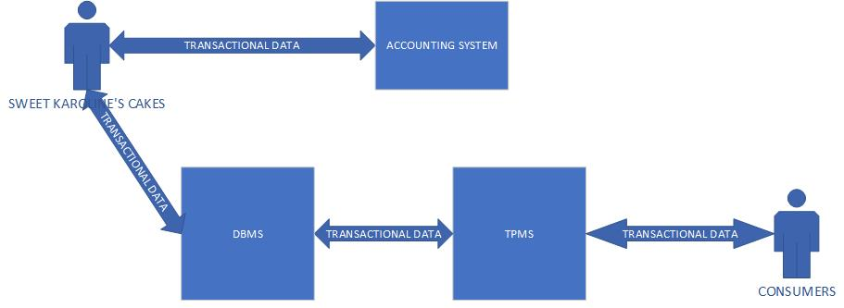

**Gantt Chart**

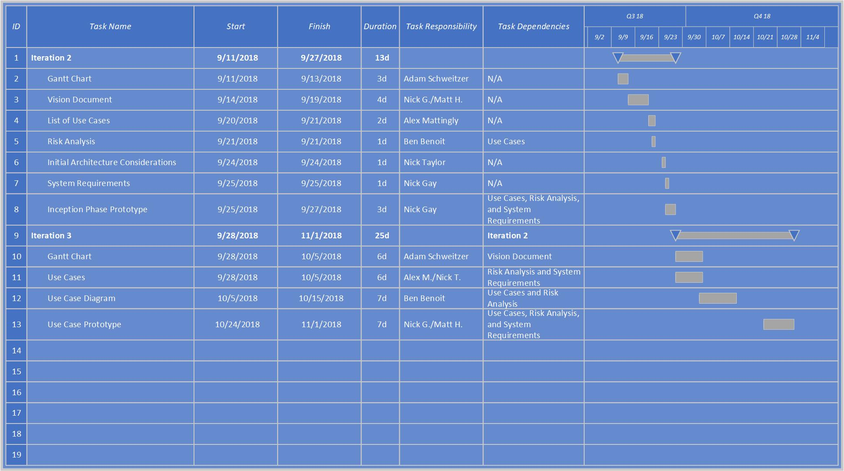

**A Gantt chart** is a type of bar chart that illustrates a project schedule. It shows dependency relationships between activities and current schedule status. It lists the tasks to be performed on the vertical axis and the time intervals on the horizontal axis. The width of the horizontal bars in the graph show the duration of each activity.

**Prototypes:**

**Prototype - Homepage:** The following image was created to give Sweet Karoline’s an idea of what the homepage of the website may look like. It includes tabs for the home page, order form, the menu, a gallery for photos of products, an about page, and the contact page. 

**Prototype - Order Form:** This is a basic prototype of what the order form will look like when the website is completed. It contains many fields that need to be filled with customer information. There is also a text box for any additional information, a calendar that lists available order dates, and the form gives the customer an option to upload a photo to give Karoline a better idea of what they want. Despite aesthetics, however, the main purpose of this form is to allow the customer to make an order, and it is designed in a way to make this an easy process.

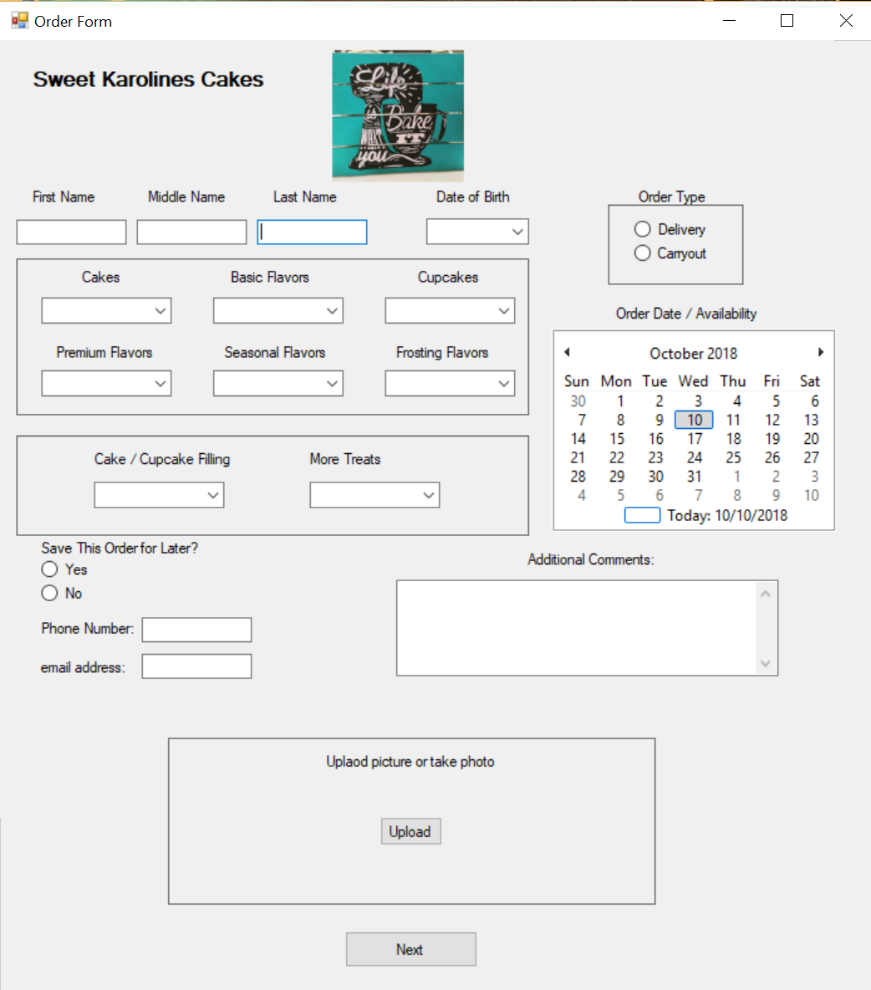

**Prototype - Payment Form:** This is a basic prototype of what the payment form will look like when the website is completed. Paypal will be the sole method of payment that is accepted, so it is displayed at the top of the form. The symbols for the various credit card companies signify that they are all processed through paypal. Since it can be a liability, Sweet Karoline’s website will not handle credit card information directly. The rest of the form consists of an order summary that displays the type of product that was ordered and the total cost. 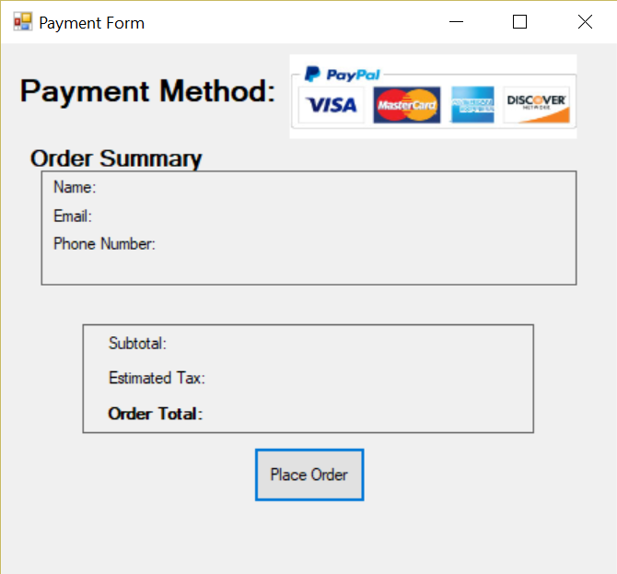

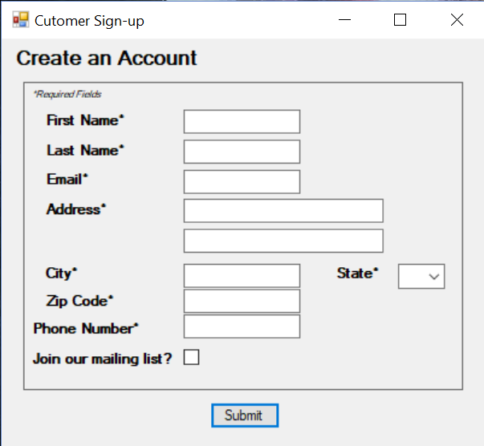

**Prototype - Account Setup:** This is a basic prototype of what the account creation form will look like when the website is completed. Nearly all of the fields require the customer to enter their information to create an account with Sweet Karoline’s Cakes. The form also includes an option to join a mailing list.

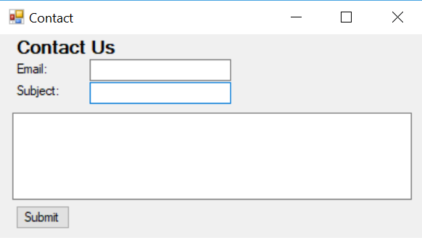

**Prototype - Contact Form:** This is a basic prototype of what the contact form will look like when the website is completed. The customer will enter their email, add a subject, and compose their message. The contact form will forward all messages to the administrative email.